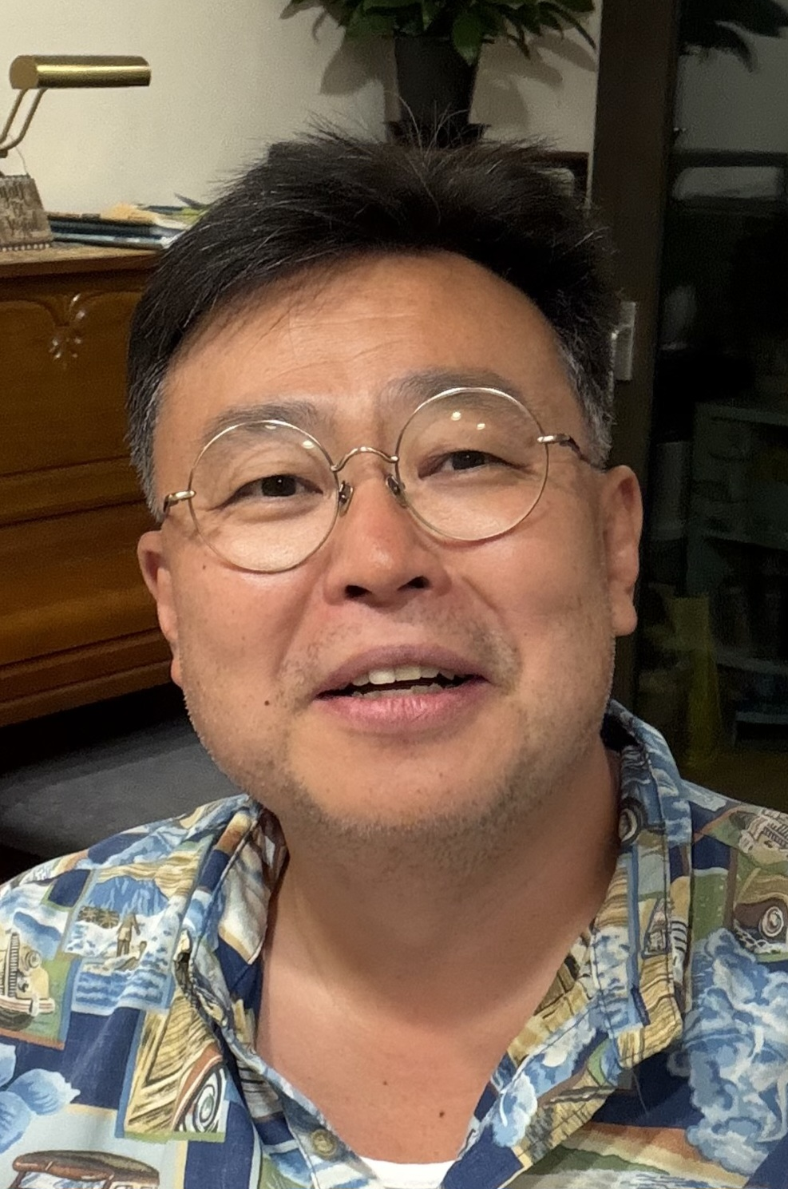

SEOKWOO LEE (D.PHIL.)
DEAN and PROFESSOR
INHA UNIVERSITY LAW SCHOOL, KOREA
E-mail: leeseokwoo@inha.ac.kr

Seokwoo LEE is Dean (2026-) and Professor of International Law, Inha University Law School, Korea (2003-), where he is also working as Director of Inha Int’l Ocean Law Centre. He was Vice Dean (Planning and Cooperation) (2024-2026) and was Vice Dean for External Affairs (2009; 2012-2014).

He was Chairman of the Foundation for the Development of International Law in Asia (DILA) (2012-2017); Co-Chair of International Law Association (ILA) Study Group, Asian State Practice of Domestic Implementation of International Law (ASP-DIIL) (2018-2022); and Vice President of the Korean Society of International Law (2019).

He was President of the Korean Branch of the International Law Association (ILA-KOREA) (2024-2025) and serving as Chairman of the Development of International Law in Asia-Korea (DILA-KOREA) (2015-) which is the academic institution which is responsible for the administration of DILA along with the Asian Yearbook of International Law (Asian YBIL) and Asia Pacific Ocean Law Institutions Alliance (APOLIA).

He is General Editor of Encyclopedia of Public International Law in Asia (EPILA) and Encyclopedia of Ocean Law and Policy in Asia-Pacific (EOLPA), Editor-in-Chief of Korean Journal of International and Comparative Law (KJICL) (Executive Editor: 2013-2023), Co-Editor-in-Chief of Asia-Pacific Journal of Ocean Law and Policy (APJOLP), Asian Yearbook of International Law (Asian YBIL), Co-Series Editor of the book series entitled Maritime Cooperation in East Asia, and Associate Editor of Brill Research Perspectives in the Law of the Sea, all published by Brill.

He has authored more than 150 publications in English in addition to his more than 100 publications in Korean. He is a graduate of Korea University where he received his undergraduate law degree (LL.B.) and then went on to receive Master of Laws (LL.M.) degrees from Korea University, the University of Minnesota, and New York University, and finally his doctorate (D.Phil.) from Oxford University. In addition, he has completed the required coursework for his doctoral degree program in Modern and Contemporary Korean History at the Department of Korean History, Korea University.

